

|  |  |
| --- | --- |
| **Module Title:** | Data Visualisation & Communication |
| **Assessment Title:** | Continuous Assignment |
| **Lecturer Name:** | Marina Iantorno |
| **Student Full Name:** | Daniel Araujo de Souza |
| **Student Number:** | 2018364 |
| **Assessment Due Date:** | 05th December 2021 |
| **Date of Submission:** |  |

**Declaration**

|  |
| --- |
| By submitting this assessment, I confirm that I have read the CCT policy on Academic Misconduct and understand the implications of submitting work that is not my own or does not appropriately reference material taken from a third party or other source. I declare it to be my own work and that all material from third parties has been appropriately referenced. I further confirm that this work has not previously been submitted for assessment by myself or someone else in CCT College Dublin or any other higher education institution. |

Table of Contents

Introduction 4

Data Analysis 5

North America Sales 5

Europe Sales 7

Japan Sales 9

Global Sales 10

Percentage of Each Genre 11

Conclusion 15

Appendix 16

References 16

Table of Figures

Figure 1 - North America sales 5

Figure 2 - Europe SAles 7

Figure 3 - Japan SAles 9

Figure 4 - Global SAles 10

Figure 5 - plot visualization separating each genre by percentage 11

Figure 6 - Most popular video game genres among internet users worldwide as of 3rd quarter 2020, by age group 12

Figure 7 - Video game sales by genre 12

Figure 8 - Global Sales based on Genres 13

# Introduction

Video games have been around for decades, from arcade games to home consoles and mobile devices. They're also on the cutting edge of computer technology.

When video games first became popular in the 1950s, they provided entertainment and people all over the world are buying new video game consoles every day, and the video game business is growing at a rapid pace. Arcade games were addictive, and people would play them for extended periods of time.

Despite several flaws in the industry in the 1980s, publishers were able to successfully manage the evolution of games, and the industry is today one of the largest in the world, managing billions of dollars annually.

The goal of this study is to present an overview of how electronic games have evolved in North America, Japan, and Europe. The analysis depicts the ups and downs of large corporations, as well as public relations strategies and large investments.

# Data Analysis

North America Sales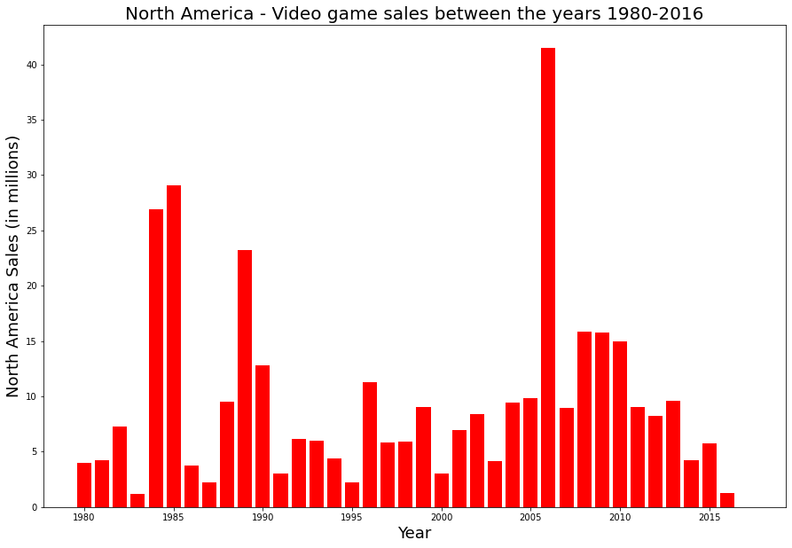

Figure 1 - North America sales

Back in the 80s when the second decade of the video games industry began, the industry was improving their games day by day as the scenario was very convenient for them. However, the market was very saturated, and the lack of quality in the games themselves drew back the industry, leading to an implosion and nearly destroying the industry in 1983.

In 1985 the industry of video games was about to get back into the "Game" with the big FAMICOM later known as the NINTENDO ENTERTAINMENT SYSTEM (NES) releasing their classic game called Super Mario Bros which is a famous game until the present days. The classic sold almost 30 million copies and helped the industry grow again.

Released in 1984 by several companies in the Soviet Union puzzle the game called “Tetris” became very famous around the world and in 1989 in North American Nintendo released a Game Boy version of the game and more than 20 million copies were sold.

In the ’90s in North America, Nintendo and Sony Computer Entertainment dominated the video game industry. In 1996 Nintendo released the famous game called “Pokémon Red and Blue” which sold more than 11 million copies. Also, Sony released the game called “Gran Turismo '' which dominates the market amongst new versions of Mario Bros as well.

In 2006 the scenario completely changed, when again the Japanese company Nintendo, which always was improving their technology and developing new games, introduced first to the North American market their incredible video game called “Wii Sports”. The game is a collection of five sports simulations, designed to demonstrate the motion-sensing capabilities of the Wii Remote. The five sports included were tennis, baseball, bowling, golf, and boxing. Players use the Wii Remote to mimic actions performed in real-life sports, such as swinging a tennis racket. The “Wii Sport” received several awards and it was considered the best video game ever made, with the incredible number of 40 million copies sold just in North America, the game became the number one of selling in 2006 and the following years until 2010.

After 2010 the video game industry changed and new consoles, technologies, and publishers were introduced to the market, by making it more accessible and affordable to everyone and becoming a very competitive market. In the 2010s Publishers such as Take-Two Interactive, Activision and Microsoft were dominating the video game world, therefore the Japanese company Nintendo lost some space in the market.

## Europe Sales

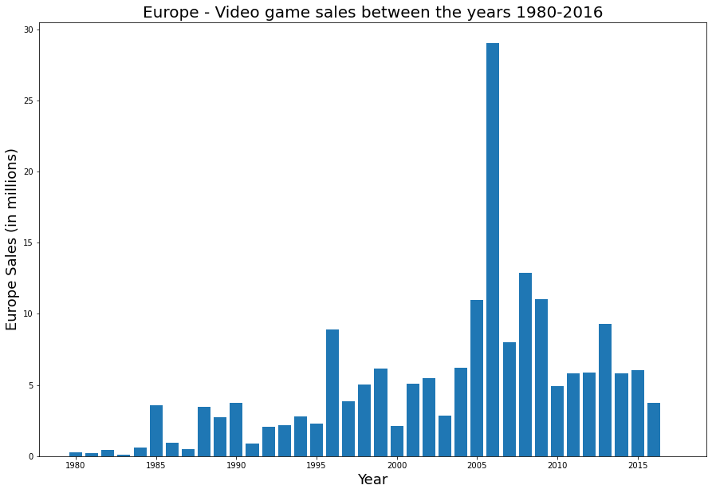

Figure 2 - Europe SAles

Japan and the United States have traditionally dominated the videogame business, with Europe primarily serving as a consumer of Japanese and North American software (video games) and hardware (video consoles). Given the prevalence of videogames as the dominant form of entertainment in our day, it is critical that Europe recognizes its current position in the industry and sets its future goals.

Before 1995, Europe was not the biggest consumer of video games in the world, not as North America and Japan, as the plot shows, buying less than 1 million every year. A few exceptions to those years were:

1985 - Year in which the game “Super Mario Bros” (NES Platform), was released, making a profit of 3,58 million only in Europe.

1988 - The same recipe seems to work, because “Super Mario Bros” (both 2 and 3 in NES Platform), are the top sold games of the year in Europe.

1989 - The following year, the Japanese Company publishes another game from the saga “Mario” and sells almost 3 million copies of the game “Super Mario Land” (Gameboy).

1990 - “Super Mario World”, 19th game most bought in the world, stresses that Nintendo has always been one of the best game publishers in the world, with a revenue of 3.75 million games sold in Europe.

Continuing with the analysis of the dataset, 1996 saw many sequels and prequels in video games, like Pokémon Red/Blue for Gameboy Advance, but the most notable achievement for the world of video games was the release of the console Nintendo 64, the first true 64-bit home console. Until the Nintendo Switch in 2017, it was the only major home system to use cartridges as its primary storage type. It competed largely with the Sony PlayStation and the Sega Saturn as a fifth-generation system.

The Nintendo 64 is one of the most well-known video game systems in history, and the titles it created have left an indelible mark on the industry; in particular, the console spawned multiple new brands as well as a vibrant speed running community that still exists today. Many of its games have been transferred to newer systems or remastered.

The highest peak happened in 2006, when more than 29 million copies of the game “Wii Sports” was sold in Europe, with the launching of Nintendo’s new console “Nintendo Wii”.

The second highest peak in Europe happened in 2008, when Nintendo sold almost 13 million copies of “Mario Kart Wii”. Another game popularized during this time was Grand Theft Auto IV, an action game published by “Take-Two Interactive”.

However, just revising the plots generated using our Dataset is insufficient to completely comprehend the present state of the European gaming industry. It's also important to know about Europe's historical experiences in the business. Only in this manner can we accurately appraise the existing situation as well as the horizon's future potential. Furthermore, our knowledge of the European gaming scenario should not be restricted to the videogame market and technical advancements. Despite the fact that defining the European video game also has a lot to do with the type of content produced and the stylistic trends of the main European creators, there is virtually no analysis of contents and design trends in European video game production (in historiographical bibliographies, specialized journals, and websites).

## Japan Sales

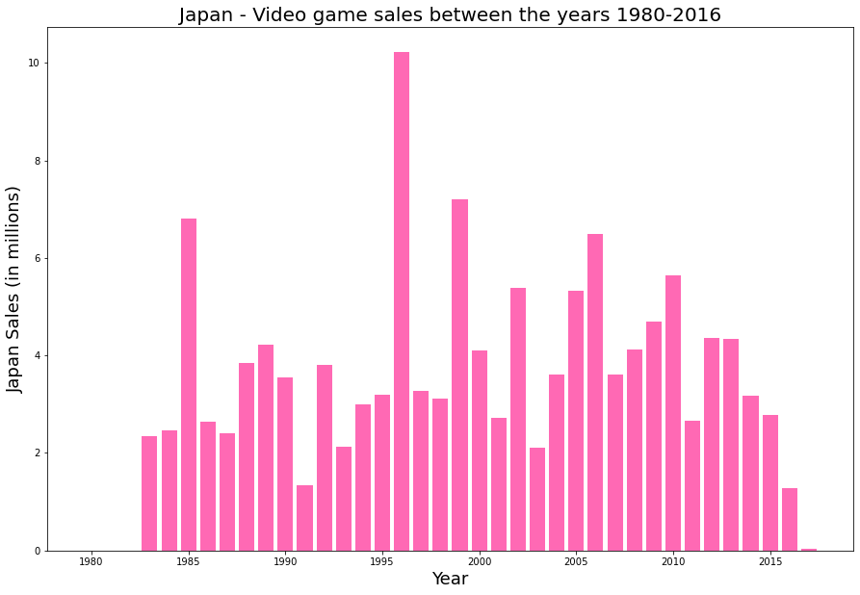

Figure 3 - Japan SAles

It would be hard to imagine that just a year after one of the worst earthquakes Japan has suffered, the country would hit a record in digital games sales. The amount reached exceeded twice its average annual acquisitions, a phenomenon. But if we study the matter further, we can see that China was at a time of rapid development, consolidated currency and a lot of involvement with the world of technology. As the text taken from Nippon (2015) describes:

“The year 1995 was a turning point for Japan in many ways. The Great Hanshin-Awaji Earthquake in western Japan and the Tokyo subway gas attack shocked the nation, while society was transformed by the release of Windows 95. The extremely high value of the yen, and the peaking in the working-age population were also significant events in this pivotal year.”

Finally, in the technology sector, there were many new features such as the Nintendo 64, the real 64bit console for home. Japan also produced many of the best games at that time, this certainly facilitated the population's access to digital games. Even in low periods, there is no sharp drop in consumption. Japan's consumerism rate is solid.

## Global Sales

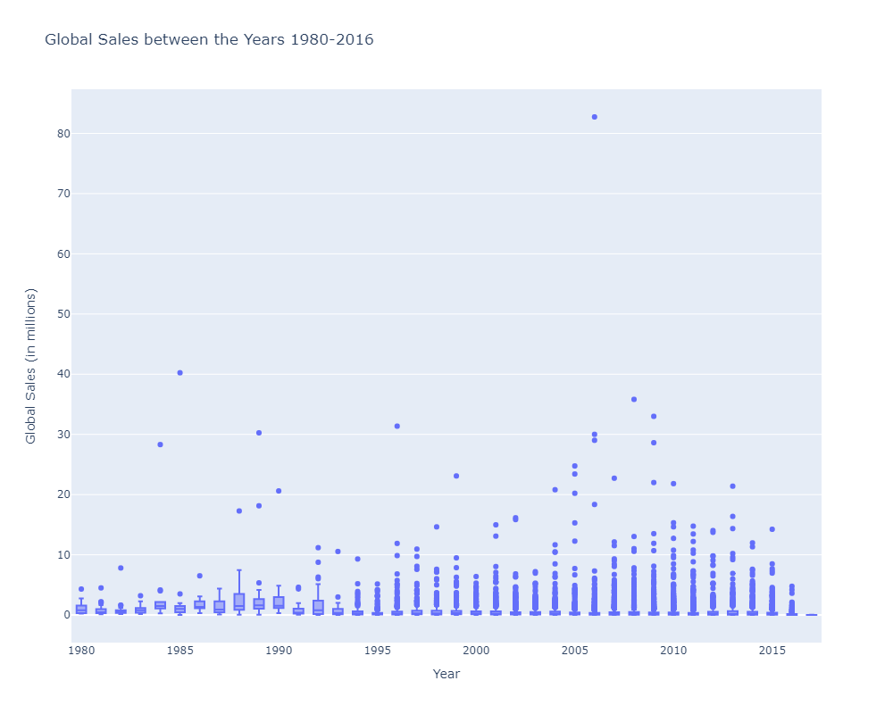

Figure 4 - Global SAles

This plot is very useful because it allows us to see where the outliers are located. It also groups the data mass, leaving more separated and distant pieces of information that are "outside the average." The video game industry reached a peak right at the dawn of the technological age in 1985, when everyone was thinking about computers a lot. Annual peaks have approached the record over time, but it wasn't until 2005, 20 years after the first peak, that we had a new record twice as high as the first.

The information we are looking for in this chart would indeed be possible to see in other types of charts, but we chose Boxplot because it gives us what is the true and real information. These would be the data that are concentrated around the median, and we treat them as natural, normal or routine. The dots are the data that came out of this normality, that is, they are abnormal data, expressive numbers that escape reality. If we want to risk a forecast, we could guess that in the year 2017 we would have another peak perhaps reaching 50% more than in 2007, but if we want to risk, even more, I will say that around 2025 this sum could double. Therefore, this consumption has been growing over and over, also there is no doubt that the gaming market is an area with a lot of space for the future, and the future we can practically predict with this graphic data.

## Percentage of Each Genre

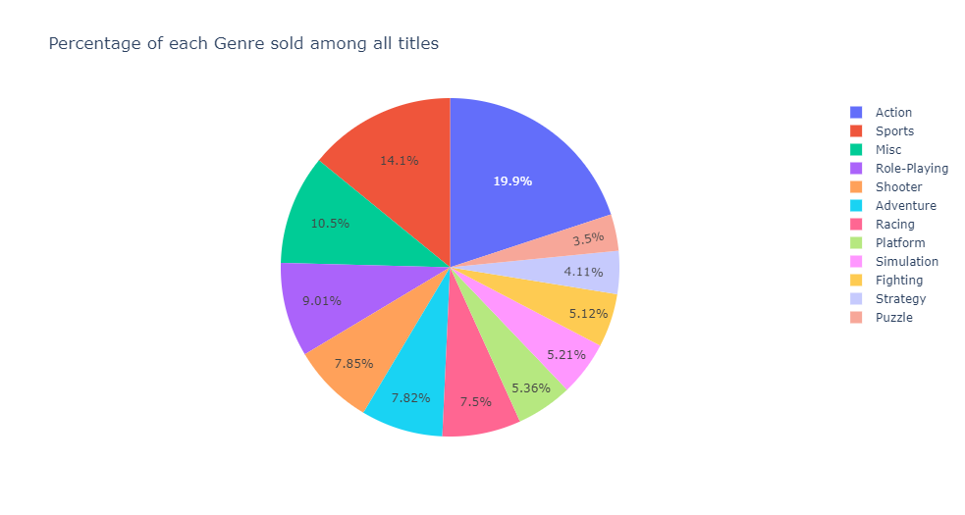

Figure 5 - plot visualization separating each genre by percentage

We can find a large number of game titles spread across the various platforms that VGChartz marketed in the dataset, with over sixteen thousand items in total.

That said, there's nothing better than using a pie chart to visualize what people like most to buy by dividing each genre in percentages. The action genre is indeed the most popular among gamers, but the sports genre isn't far behind. An interesting fact is that racing games were not very well known at the time, but as we can see now, the Racing genre has more than doubled its preferred purpose.

It would be simple to categorize today's wide range of games into just a few categories, such as Action, Sports, or Miscellaneous. However, if you search the internet for game preferences, you'll come across genre types that are somewhat novel, such as the ones found in this Statista survey.

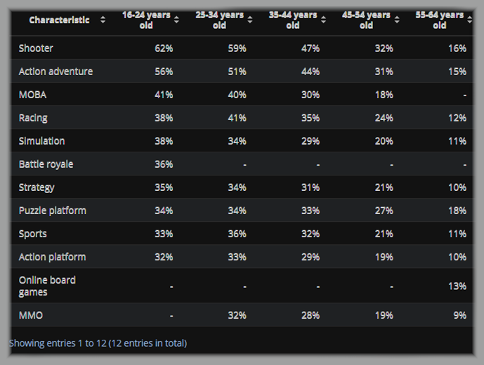

Figure 6 - Most popular video game genres among internet users worldwide as of 3rd quarter 2020, by age group

The curious part about it is that we can see, perhaps indirectly, great similarity in these data. This survey above was conducted four years after our data thus we can see the predominance of genres on the shelves. This same trend can be seen in graphs from other sources, such as the one below, which was published by VGChartz.com:

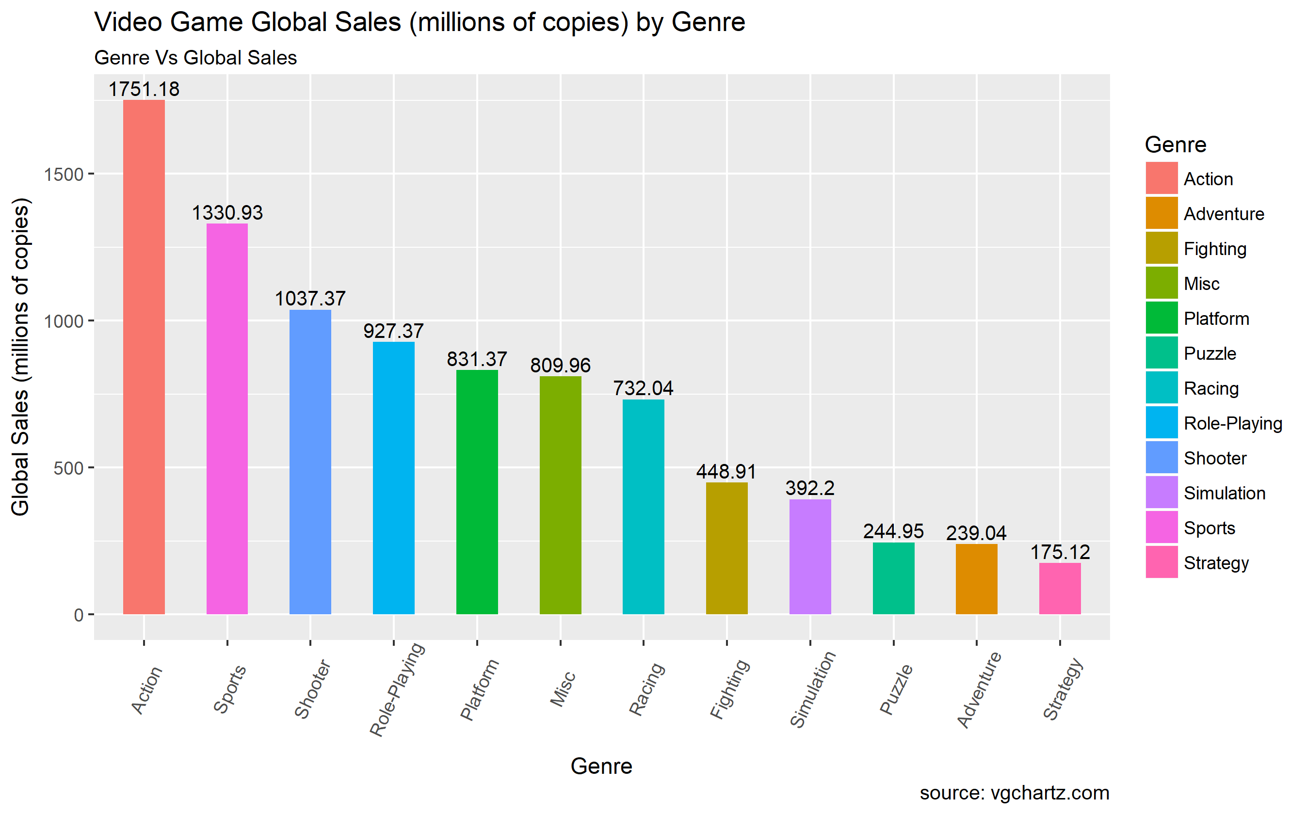

Figure 7 - Video game sales by genre

Since the 2000s, what was new has taken shape quickly and has been increasingly innovated and improved. The audience no longer prefers 8-bit games as their preferred form of entertainment. Modern action games, on the other hand, with fast scene changes, explosions, and graphic visuals, have gained more traction in both the public's preference and the market.

This is all very interesting, and if we look at our graph, we can even make some predictions about what might not happen and what might happen in the future. Remember that these are historical data spanning from 1980 to 2016, with ups and downs along the way. Our project, which uses the Dataset provided by VGChartz*, allows us to provide this information in detail, but let's compare this performance by looking at our chart, which was created specifically to show, in general, the most and least requested genres over the years. Take a look at the following graph: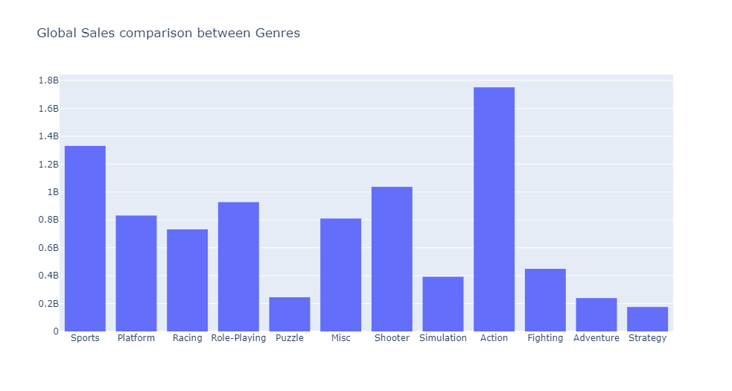

Figure 8 - Global Sales based on Genres

Regardless of the research described above, analysing these graphs reveals a spike in the action genre, and because this genre can refer to a variety of games, there was an increase in game acquisition as the years passed, but the genre "Action" remained dominating. It's the same record year after year, and if we go back to the charts indicated above, the result was almost identical to our VGChartz Dataset. As a result, we are sure that the action genre will continue to gain traction in the geek market in the long run.

Sports were never forgotten by gamers, especially with the introduction of the PlayStation into society and, later, all these games that could be played in online battles.

Strategy games were also never a poor choice. The strategy genre has demonstrated to be consistent in its evolution, with its audience remaining stable and devoted since the beginning of the story. It is more popular among gamers that prefer to think more during the game. There are several processes, rules, and characteristics that a game must have in order to be successful with its audience nowadays but let us agree that a good game engrosses you from beginning to end, the story engrosses you, the characters engross you, and the soundtrack engross you, so there is no one genre that is the best among gamers. Every genre is enjoyable, each game is distinct, and each player will face off against another player in that game.

# Conclusion

Our findings reveal what seems to be a recurring pattern in North American, European and Japanese video game history, when new consoles and technologies are created, there is a peak of game sales.

We understand as well that the Japanese multinational consumer electronics and video game company Nintendo holds the position of one of the biggest publishers in the world, having launched internationally recognisable titles (and sagas) as Mario Bros, Pokémon, The Legend of Zelda and others.

For the future, a more detailed approach would be needed as we have mentioned in the introduction, the aim of this report was to outline a review of the dataset, exploring the ups and downs of the video game industry. The major attention being the past years, as recent times new technologies have had a rapid growth, like new games modalities and genres, new consoles as PlayStation 5, Nintendo Switch and others, technologies exploring VR (virtual reality) and AR (augmented reality) and mobile games.

## Appendix

Word Count: 2332 words.

# References

Clement, J., 2021. *Top video game genres worldwide by age 2020 | Statista*. [online] Statista. Available at: <https://www.statista.com/statistics/1263585/top-video-game-genres-worldwide-by-age/> [Accessed 3 December 2021].

Clement, J., 2021. *Top video game genres worldwide by age 2020 | Statista*. [online] Statista. Available at: <https://www.statista.com/statistics/1263585/top-video-game-genres-worldwide-by-age/> [Accessed 3 December 2021].

Clement, J., 2021. *U.S. most popular video game genres 2018 | Statista*. [online] Statista. Available at: <https://www.statista.com/statistics/189592/breakdown-of-us-video-game-sales-2009-by-genre/> [Accessed 5 December 2021].

Curtis, C., Nettuno, T., Huff, C., Staff, F., Staff, F., Nettuno, T., Nettuno, T., Staff, F., Staff, F. and Huff, C., 2021. *Ranking the 10 greatest sports video games of all time*. [online] For The Win. Available at: <https://ftw.usatoday.com/lists/best-sports-video-games-all-time> [Accessed 3 December 2021].

Hosa. 2021. *History of Gaming Setups - 80's, 90's & 00's - Hosa*. [online] Available at: <https://hosatech.com/press-release/history-of-video-games/> [Accessed 2 December 2021].

LLC, B., 2021. *What was the Great Video Game Crash of 1983? | BugSplat Blog*. [online] Bugsplat.com. Available at: <https://www.bugsplat.com/blog/less-serious/great-video-game-crash-1983/> [Accessed 5 December 2021].

Magazine, S., 2021. *Thirty Years Ago, Game Boy Changed the Way America Played Video Games*. [online] Smithsonian Magazine. Available at: <https://www.smithsonianmag.com/innovation/thirty-years-ago-game-boy-changed-way-america-played-video-games-180972743/> [Accessed 3 December 2021].

Mordorintelligence.com. 2021. *Global Gaming Market | 2021 - 26 | Industry Share, Size, Growth - Mordor Intelligence*. [online] Available at: <https://www.mordorintelligence.com/industry-reports/global-gaming-market> [Accessed 1 December 2021].

nippon.com. 2021. *A Pivotal Year: Japan in 1995*. [online] Available at: <https://www.nippon.com/en/series/a-pivotal-year-japan-in-1995/> [Accessed 2 December 2021].

Pérez Latorre, Ó., 2013. *The European videogame: An introduction to its history and creative traits*. Spain: European Journal of Communication.

Starmer, J., 2021. *Boxplots are Awesome*. [online] Youtube.com. Available at: <https://www.youtube.com/watch?v=fHLhBnmwUM0> [Accessed 3 December 2021].

Tetris, 2021. *History of Tetris®*. [online] Tetris. Available at: <https://tetris.com/history-of-tetris> [Accessed 2 December 2021].

VGChartz. 2021. *Video Game Charts, Game Sales, Top Sellers, Game Data - VGChartz*. [online] Available at: <https://www.vgchartz.com/> [Accessed 1 December 2021].

Vgsales, 2021. *Video game industry*. [online] Video Game Sales Wiki. Available at: <https://vgsales.fandom.com/wiki/Video_game_industry> [Accessed 5 December 2021].